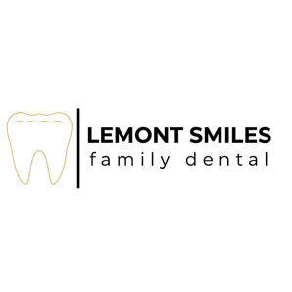
Assignment and Release of Medical Information

Our notice of Privacy Practices provides information about how we may use and disclose health information about you. The notice contains a Patient Rights section describing your rights, under the law. You have the right to review our notice before signing this Consent. The terms of this notice may change. I few change our Notice, you may obtain a revised copy at your request.

In consideration of medical treatment to be received, I do hereby assign, transfer and set over to Lemont Smiles Family Dental. All my rights, title and interest in the above identified health insurance policy/policies to the extend of the benefits available. I understand that I am financially responsible for the charges not covered by my insurance company.

Signed: __________________________________________________ Date: _________________________

Acknowledgement of receipt of Notice of Privacy Practices
*You may refuse to sign the acknowledgement*

I have received a copy of Lemont Smiles Family Dental Notice of Privacy Practices.

Print Name: _____________________________________________________________________________

Signature: ________________________________________________ Date: ________________________

Consent for Dental Treatment

I certify that I have read and understand the above questions and acknowledge that questions have been answered to the best of my knowledge. I hereby authorize the dentist and dental staff to perform diagnostic procedures and treatment as may be necessary for proper dental care. I understand that no guarantees have been made regarding treatment outcomes.

I acknowledge that I am responsible for all fees incurred for services rendered, regardless of insurance coverage.

Patient/Guardian Name (print): ________________________________________________________

Signature: ___________________________________________ Date: ________________________

